CHAPTER 1
COMPANY
  - Company Profile
EduPhoenix Solutions is a dynamic and innovative company dedicated to providing cutting-edge solutions in the field of education technology. Established with a vision to revolutionize learning experiences, EduPhoenix Solutions offers a comprehensive range of products and services tailored to meet the evolving needs of educational institutions, students, and educators.
At EduPhoenix Solutions, we leverage the latest advancements in technology to develop intuitive and interactive educational platforms, tools, and resources. Our team of experts is committed to designing and delivering solutions that enhance teaching effectiveness, engage learners, and foster academic success.
From e-learning platforms and virtual classrooms to customized educational software and mobile applications, EduPhoenix Solutions offers a diverse portfolio of products aimed at transforming traditional learning paradigms. We prioritize user-centric design, ensuring that our solutions are user-friendly, accessible, and adaptable to diverse learning environments.

Figure 1.1 Company Logo
In addition to our innovative products, EduPhoenix Solutions provides consultancy services, training programs, and ongoing support to help educational institutions maximize the impact of technology on teaching and learning outcomes. Our collaborative approach enables us to work closely with clients to understand their unique challenges and goals, delivering tailored solutions that drive positive change and innovation.
EduPhoenix Solutions stands at the forefront of educational technology, driven by a passion for innovation and a commitment to excellence. With a deep understanding of the challenges facing modern educational institutions, we offer a comprehensive suite of solutions designed to elevate teaching and learning experiences to new heights.
Our team of experts combines extensive experience in both education and technology to develop cutting-edge platforms and tools that empower educators and engage learners. By harnessing the latest advancements in artificial intelligence, data analytics, and user-centric design, we create intuitive and immersive learning environments that foster creativity, critical thinking, and collaboration.
Beyond our innovative products, EduPhoenix Solutions provides strategic consultancy services and professional development programs to support educational institutions in leveraging technology effectively. From needs assessment and solution design to implementation and ongoing support, we partner with our clients every step of the way to ensure the success of their digital initiatives.
With a strong focus on user experience, accessibility, and scalability, our solutions are tailored to meet the unique needs of diverse educational settings, from K-12 schools to higher education institutions and corporate training programs. By delivering customizable, adaptable, and future-ready solutions, we empower educators to deliver high-quality instruction and empower learners to achieve their full potential in an increasingly digital world.
Driven by a shared vision of transforming education through technology, EduPhoenix Solutions is dedicated to pushing the boundaries of innovation and driving positive change in the education landscape. As we continue to evolve and expand our offerings, we remain steadfast in our commitment to delivering impactful solutions that inspire lifelong learning and shape the future of education.
With a commitment to excellence, integrity, and continuous improvement, EduPhoenix Solutions is dedicated to empowering educators, inspiring learners, and shaping the future of education through technology. We are proud to partner with educational institutions worldwide, helping them unlock the full potential of digital learning in the 21st century.

1.2 Company Overview
EduPhoenix Solutions is a dynamic and forward-thinking company that specializes in providing innovative educational technology solutions to institutions worldwide. Established with a vision to revolutionize the way education is delivered and experienced, EduPhoenix Solutions has quickly emerged as a leader in the field, offering a wide range of cutting-edge products and services tailored to meet the diverse needs of educators and learners alike.
At EduPhoenix Solutions, we believe that technology has the power to transform education by making learning more accessible, engaging, and effective. With this belief at the core of our mission, we strive to develop solutions that empower educators to deliver high-quality instruction and enable learners to reach their full potential.
Our comprehensive suite of products and services encompasses everything from learning management systems and virtual classrooms to interactive content authoring tools and professional development programs. Whether it's providing educators with the tools they need to create immersive learning experiences or offering learners access to dynamic and interactive learning environments, EduPhoenix Solutions is committed to driving positive change in education through technology.
One of the key strengths of EduPhoenix Solutions lies in our team of experts, who bring a wealth of experience and expertise from diverse fields such as education, technology, instructional design, and user experience. By combining our knowledge and skills, we are able to develop innovative solutions that address the evolving needs of the education sector and deliver measurable results.
In addition to our product offerings, EduPhoenix Solutions also provides consultancy services to educational institutions seeking to leverage technology effectively. From needs assessment and solution design to implementation and ongoing support, our team works closely with clients to develop customized strategies and solutions that align with their unique goals and objectives.
As a company, we are deeply committed to excellence, integrity, and customer satisfaction. We take pride in our ability to deliver high-quality products and services that meet the highest standards of quality and reliability. With a customer-centric approach and a focus on continuous improvement, we strive to exceed our clients' expectations and build long-lasting partnerships based on trust and mutual respect.

  - Company Departments
EduPhoenix Solutions operates across several departments, each contributing to the overall mission of delivering innovative educational solutions and services. These departments include:

Human Resources (HR) Department:
Recruitment and Talent Acquisition: This involves identifying staffing needs, sourcing candidates through job postings and recruitment agencies, conducting interviews, and selecting the best-fit candidates.
Employee Onboarding and Orientation: HR ensures that new hires receive necessary training, complete required paperwork, understand company policies, and integrate smoothly into their roles and the organization.
Performance Management: HR oversees performance evaluations, goal setting, feedback mechanisms, and recognition programs to foster employee growth, development, and engagement.
Employee Relations: This department handles employee grievances, conflicts, disciplinary actions, and ensures compliance with employment laws and regulations.
Training and Development: HR designs and implements training programs, workshops, and seminars to enhance employee skills, competencies, and professional development opportunities.
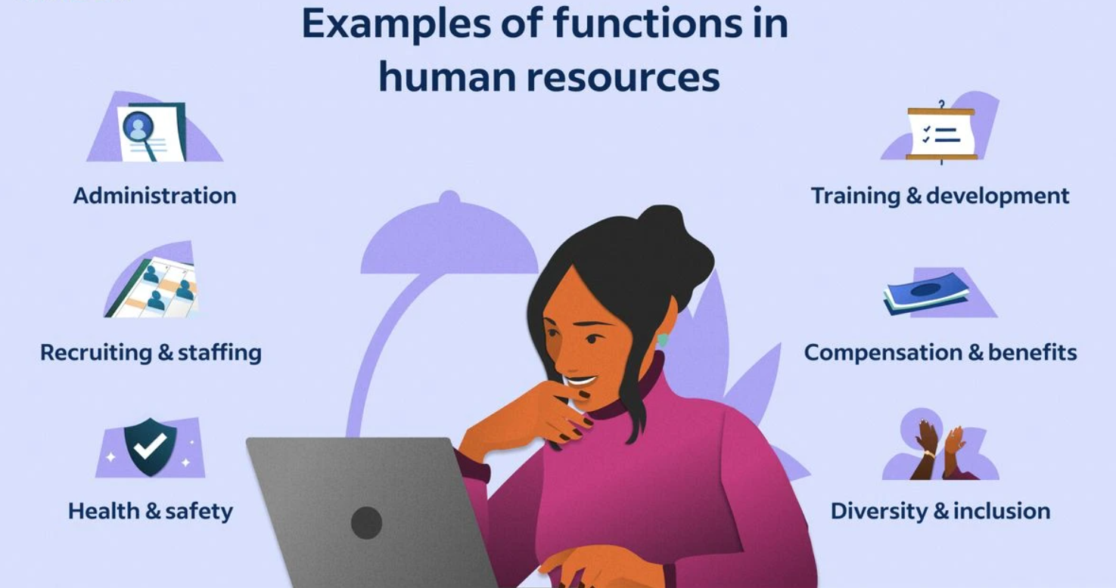
Figure 1.3.1 Functions of Human Resources (HR)

Information Technology (IT) and Technical Support Department:
Infrastructure Management: This includes managing servers, networks, hardware, and software systems to ensure seamless operation, security, and scalability.
Systems Administration: IT administrators monitor system performance, troubleshoot technical issues, install updates, and ensure data backups and recovery protocols are in place.
Cybersecurity: This team protects the organization from cyber threats by implementing firewalls, antivirus software, intrusion detection systems (IDS), and conducting regular security audits and assessments.
Software Development: IT professionals develop and maintain custom software applications, websites, and digital platforms to support internal operations and customer-facing solutions.
Technical Support: The IT helpdesk provides technical assistance, resolves user issues, and offers guidance on software usage, hardware configuration, and network connectivity.
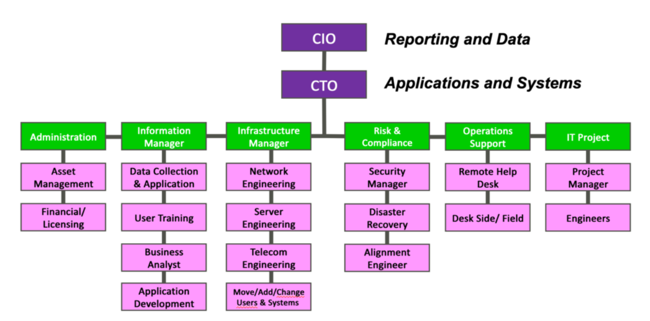
Figure 1.3.2 Information Technology (IT) Department Structure

Research and Development (R&D) Department:
Market Research and Analysis: R&D conducts market research to identify industry trends, customer preferences, and competitive landscapes to inform product development strategies.
Product Innovation: This team conceptualizes and prototypes new products, features, and services, leveraging emerging technologies and customer feedback to drive innovation.
Prototype Development: R&D builds and tests prototypes to validate concepts, assess feasibility, and gather user feedback before full-scale development and commercialization.
Intellectual Property Management: This involves securing patents, trademarks, and copyrights to protect the organization's innovations, inventions, and creative works from infringement.
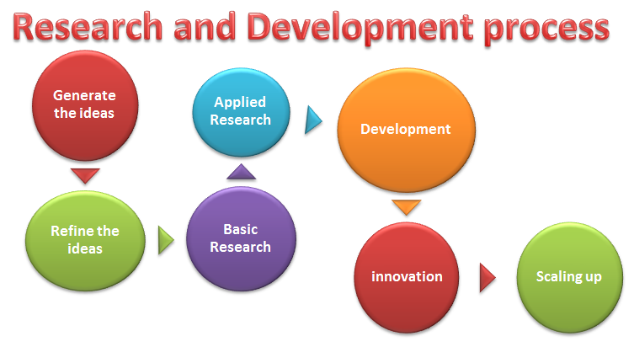
Figure1.3.3 Research & Development Process

Sales and Marketing Department:Market Segmentation and Targeting: Sales and marketing professionals identify and segment target markets based on demographics, behaviors, and preferences to tailor marketing messages and campaigns.
Lead Generation and Nurturing: This team generates leads through advertising, content marketing, and networking efforts, then nurtures those leads through email campaigns, follow-up calls, and personalized communication.
Brand Management: Sales and marketing professionals develop brand identity, messaging, and positioning strategies to differentiate EduPhoenix Solutions from competitors and build brand loyalty.
Digital Marketing: This involves leveraging digital channels such as websites, social media platforms, search engine optimization (SEO), and pay-per-click (PPC) advertising to reach and engage target audiences.
Sales Enablement: Sales enablement teams provide sales reps with the tools, resources, and training needed to effectively communicate product features, benefits, and value propositions to prospects and customers.

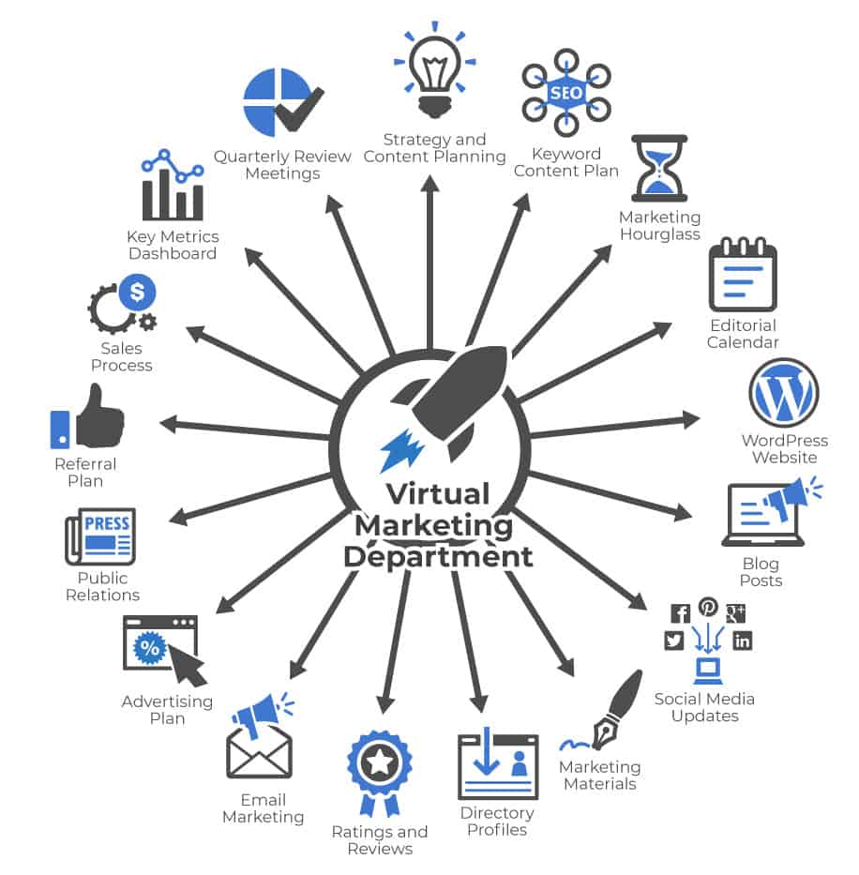
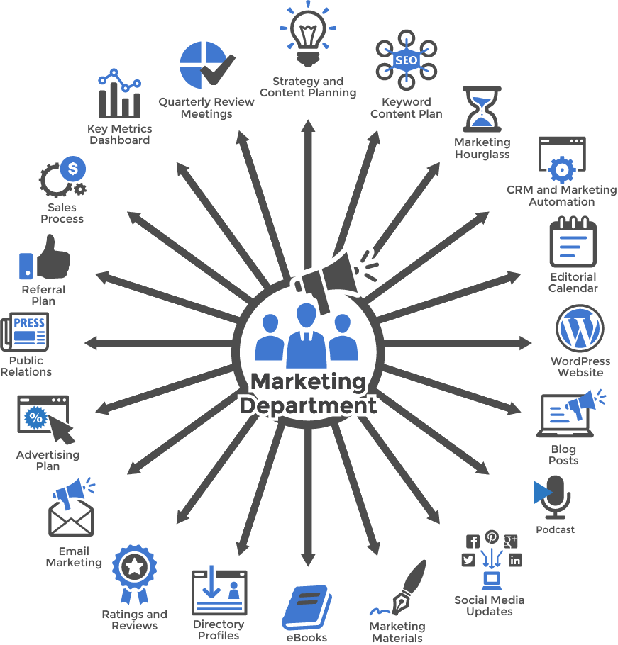
Figure 1.3.4(a) Virtual Marketing  Department | Figure 1.3.4(b) Marketing  Department

Customer Success Department:
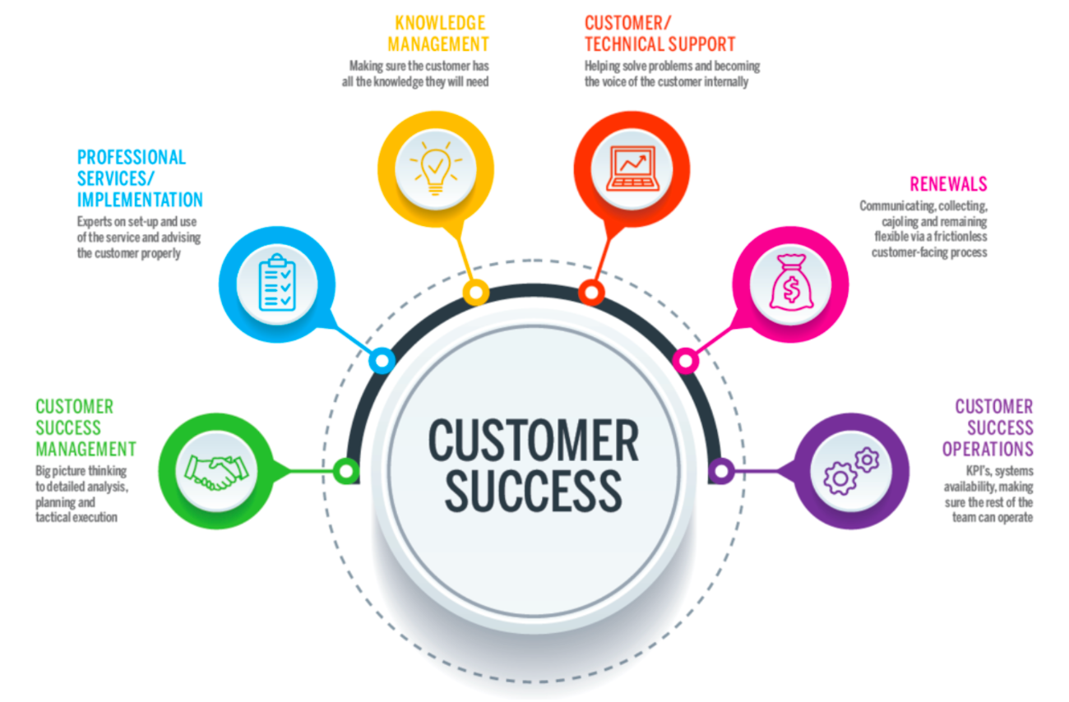
Customer Onboarding: This involves guiding new customers through the implementation process, providing training, support, and resources to ensure successful adoption and utilization of EduPhoenix Solutions.
Figure 1.3.5 Customer Success
Customer Relationship Management: Customer success managers build and nurture relationships with clients, acting as their advocate within the organization and ensuring their needs and expectations are met.
Account Management: This team is responsible for managing customer accounts, identifying upsell and cross-sell opportunities, and fostering long-term relationships to drive retention and expansion.
Customer Support: The customer support team provides responsive assistance, troubleshooting, and issue resolution to address customer inquiries, technical challenges, and service disruptions effectively.

Finance and Accounting Department:
Financial Planning and Analysis: This department is responsible for budgeting, forecasting, financial modeling, and providing insights to support strategic decision-making.
Accounts Payable and Receivable: Finance professionals manage payments to vendors, invoicing customers, and tracking receivables to ensure timely cash flow management.
Financial Reporting and Compliance: This team prepares financial statements, regulatory filings, and ensures compliance with accounting standards, tax laws, and industry regulations.
Treasury Management: Finance professionals oversee cash management, investment strategies, and risk mitigation to optimize liquidity and financial stability.

Figure 1.3.6 Finance & Accounting

Legal and Compliance Department:
Contract Management: Legal professionals draft, review, and negotiate contracts with clients, partners, and vendors to protect EduPhoenix Solutions' interests and mitigate legal risks.
Regulatory Compliance: This team ensures compliance with laws, regulations, and industry standards related to data privacy, security, intellectual property, and consumer protection.
Intellectual Property (IP) Management: Legal experts manage EduPhoenix Solutions' intellectual property portfolio, including patents, trademarks, copyrights, and trade secrets.
Risk Management: The legal and compliance department identifies, assesses, and manages legal and regulatory risks to minimize exposure and protect the organization from liabilities.
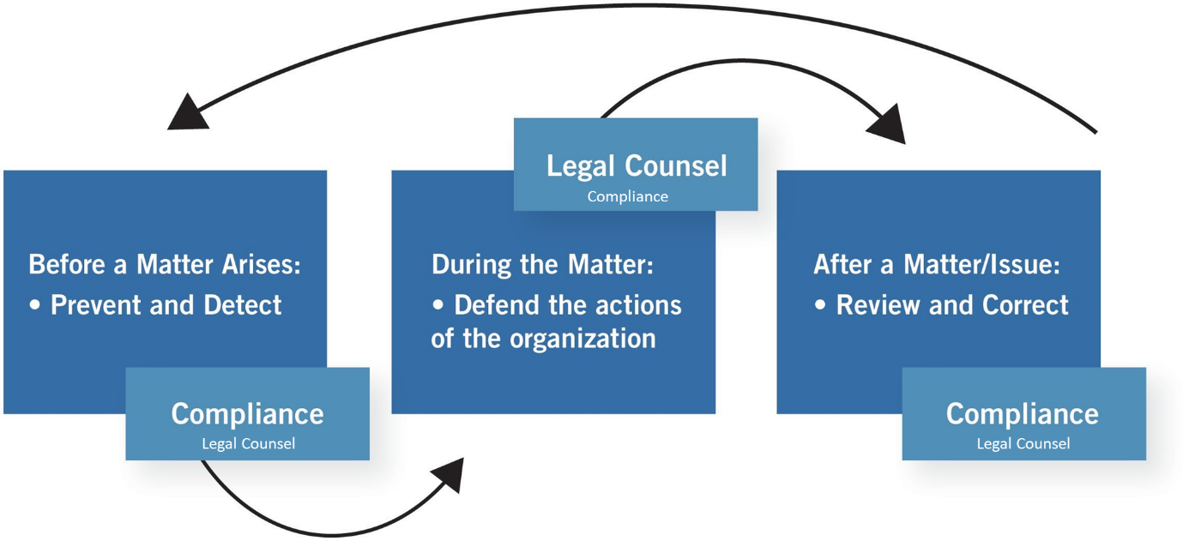
Figure 1.3.7 Legal & Compliance Procedure

Operations and Logistics Department:
Supply Chain Management: Operations professionals oversee procurement, inventory management, and logistics to ensure timely delivery of goods and services while optimizing costs and efficiency.
Facilities Management: This team maintains and manages office facilities, equipment, and infrastructure to create a safe, productive, and comfortable work environment.
Quality Assurance and Control: Operations experts develop and implement quality standards, processes, and metrics to ensure products and services meet or exceed customer expectations.

Figure 1.3.8(a) Operations  Management | Figure 1.3.8(b) Logistics

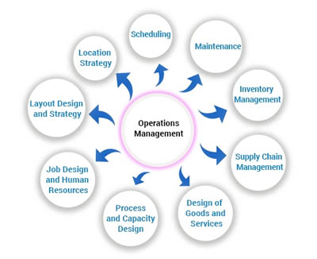

Project Management: Operations professionals coordinate cross-functional projects, allocate resources, and track progress to ensure timely completion and successful outcomes.

Customer Experience Department:
User Experience (UX) Design: This team focuses on designing intuitive, user-friendly interfaces and interactions for digital products and platforms to enhance customer satisfaction and engagement.
Customer Insights and Analytics: CX professionals analyze customer feedback, behavior data, and performance metrics to gain actionable insights and drive continuous improvement initiatives.
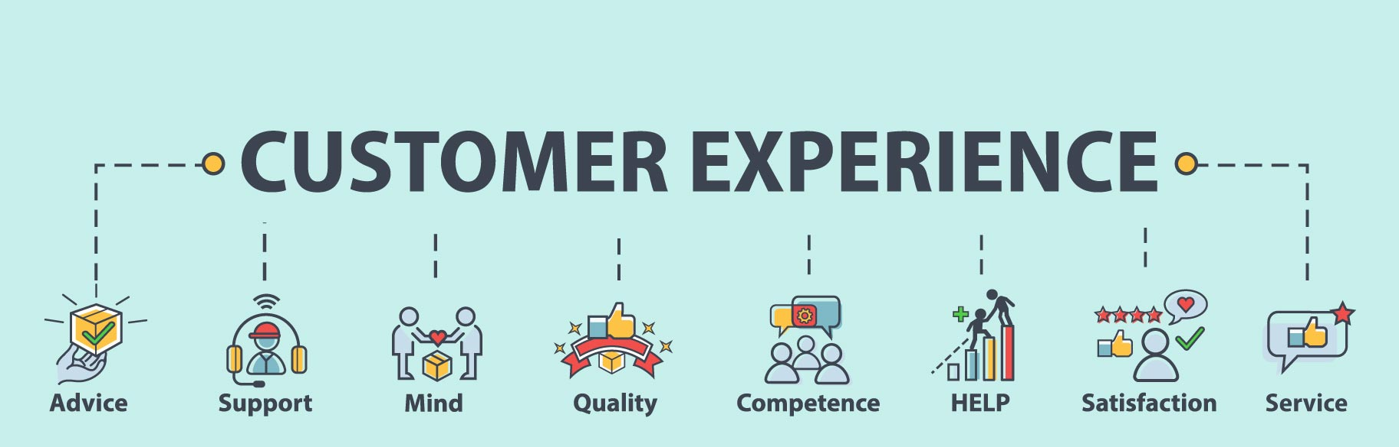
Customer Advocacy: This department represents the voice of the customer within the organization, advocating for their needs, preferences, and concerns to inform product development and decision-making.
Figure 1.3.9 Customer Experience
Customer Satisfaction and Retention: CX professionals develop strategies and programs to measure and improve customer satisfaction, loyalty, and retention rates through proactive engagement and personalized experiences.

Business Development and Partnerships Department:
Strategic Partnerships: Business development professionals identify and cultivate strategic alliances, joint ventures, and partnerships with other companies to expand market reach, access new resources, and drive growth.
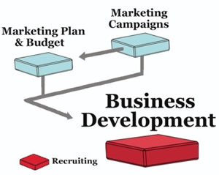
Market Expansion: This team explores new markets, geographies, and customer segments to identify growth opportunities and develop market entry strategies to capitalize on emerging trends.
Channel Development: Business development experts establish and manage distribution channels, reseller networks, and affiliate programs to extend EduPhoenix Solutions' reach and increase sales volume.
Competitive Intelligence: This department monitors competitors' activities, market trends, and industry developments to identify threats and opportunities, inform strategic decision-making, and maintain a competitive edge. Figure 1.3.10 Business Development

Quality Assurance and Testing Department:
Quality Assurance (QA) Testing is a critical function that ensures products and services meet specified quality standards before they are released to customers. This involves systematically testing various aspects of software, hardware, or other deliverables to identify defects or areas for improvement.
QA testers develop comprehensive test plans, scenarios, and scripts based on project requirements and specifications. These documents outline the testing approach, test cases, and expected outcomes for each test scenario.
Different types of testing are performed throughout the development lifecycle, including functional testing, which verifies that the system meets specified functional requirements, and regression testing, which ensures that new changes do not adversely impact existing functionality.

Figure 1.3.11(a) Quality Assurance | Figure 1.3.11(b) Testing

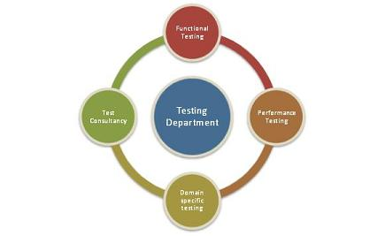
User acceptance testing (UAT) is conducted to validate the product against user expectations and requirements. This involves engaging end-users to evaluate the product's usability, accessibility, and overall user experience.
QA testers use a variety of testing techniques and tools to identify defects and bugs in the system. This may include manual testing, automated testing, performance testing, security testing, and usability testing, among others.
Throughout the testing process, QA testers document their findings, including any defects or issues discovered during testing. They work closely with development teams to prioritize and address these issues, ensuring that high-priority defects are resolved promptly.
Continuous improvement is a key aspect of QA testing, with testers regularly reviewing and refining testing processes and methodologies to enhance efficiency and effectiveness. This may involve implementing new tools, adopting best practices, and incorporating feedback from stakeholders to drive quality improvements.
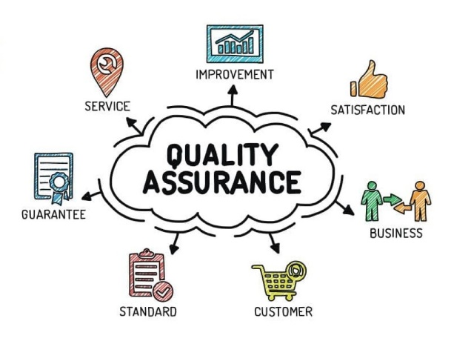
Grievance and Conflict Resolution Department:
The Grievance and Conflict Resolution department is responsible for managing disputes, grievances, and conflicts within the organization. This department serves as a neutral mediator, helping parties resolve issues in a fair and equitable manner.
One of the primary functions is to provide employees and stakeholders with a platform to express their concerns and grievances. This could involve setting up confidential reporting mechanisms, such as hotlines or online portals, where individuals can raise issues anonymously.
The department investigates complaints and conflicts thoroughly, gathering relevant information and evidence to understand the root causes of the problem. Depending on the nature of the issue, this may involve conducting interviews, reviewing documentation, or engaging in alternative dispute resolution methods like mediation or arbitration.
Once the investigation is complete, the department works towards finding a resolution that addresses the concerns of all parties involved. This could involve implementing corrective actions, revising policies or procedures, or providing training and support to prevent similar issues from arising in the future.
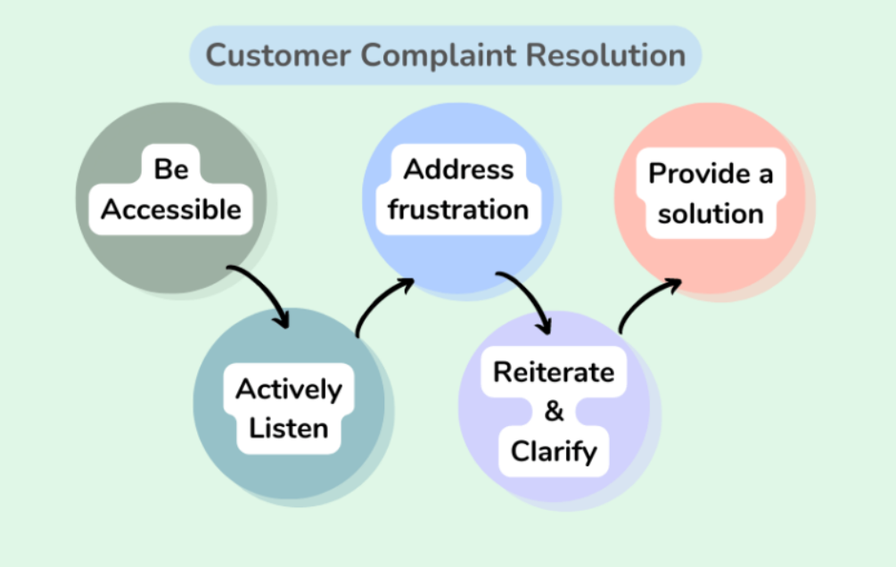
Figure 1.3.12 Customer Complaint Resolution
Additionally, the Grievance and Conflict Resolution department may play a role in promoting a positive organizational culture by fostering open communication, trust, and collaboration among employees. This includes promoting conflict resolution skills and providing resources for managing interpersonal conflicts effectively.

These departments play integral roles in ensuring the success and growth of EduPhoenix Solutions by effectively managing resources, delivering high-quality products and services, and delivers comprehensive educational solutions that empower learners, educators, and institutions to succeed in a rapidly evolving digital landscape.

  - Company Products/Applications
EduPhoenix Solutions prides itself on offering a diverse array of cutting-edge educational technology products and applications designed to cater to the evolving needs of educators and learners alike. Our commitment to innovation and excellence drives us to develop solutions that enhance teaching effectiveness, promote student engagement, and ultimately elevate the learning experience. Here's a detailed overview of our key products and applications:
- Learning Management System (LMS):
Our Learning Management System (LMS) serves as the cornerstone of our educational technology suite. This robust platform provides educators with the tools they need to create, deliver, and manage online courses and educational content seamlessly. With intuitive course creation features, comprehensive content management capabilities, and robust assessment tools, our LMS empowers educators to design dynamic and interactive learning experiences. Moreover, real-time analytics and reporting functionalities enable educators to monitor student progress and performance effectively.

- Virtual Classroom:
In today's digital age, our Virtual Classroom platform offers educators a versatile and immersive online learning environment. Equipped with video conferencing, screen sharing, interactive whiteboards, and chat functionality, this platform facilitates real-time collaboration and interaction between educators and students. Whether conducting live classes, webinars, or virtual workshops, educators can engage learners effectively and foster meaningful learning experiences. Seamless integration with our LMS ensures streamlined course delivery and administration.

- Interactive Content Authoring Tools:
Our suite of interactive content authoring tools empowers educators to create engaging and multimedia-rich learning materials with ease. Featuring user-friendly interfaces, customizable templates, and multimedia integration capabilities, these authoring tools enable educators to develop interactive presentations, quizzes, simulations, and games effortlessly. With built-in assessment and tracking features, educators can assess student comprehension and progress in real time, ensuring that learning objectives are met effectively.

- Professional Development Programs:
Recognizing the importance of continuous professional development, we offer a wide range of training courses and programs designed to enhance educators' skills and knowledge in educational technology and pedagogy. From digital literacy and blended learning to instructional design and technology integration, our professional development programs cover a diverse array of topics. Whether educators are looking to expand their expertise in specific areas or earn certifications in educational technology, our programs provide valuable opportunities for growth and advancement.
- Consultancy Services:
Our consultancy services cater to educational institutions seeking expert guidance and support in leveraging technology for teaching and learning. Our team of seasoned consultants collaborates closely with clients to assess their unique needs, develop tailored technology solutions, and provide ongoing training and support. From strategic planning and needs analysis to implementation and evaluation, our consultancy services empower institutions to maximize the impact of educational technology and achieve their educational goals effectively.

- IoT Projects:
Internet of Things (IoT) projects involve the integration of physical devices, sensors, and software applications to enable connectivity and data exchange. These projects often focus on leveraging IoT technologies to create smart systems, automate processes, and gather insights from real-world data. Eduphoenix Solutions offers a range of IoT projects aimed at providing hands-on learning experiences to students and professionals.
These projects typically cover areas such as:
Sensor Integration: Students learn to integrate various sensors such as temperature sensors, humidity sensors, motion sensors, and environmental sensors into IoT devices and systems.
Data Acquisition and Processing: Projects involve collecting data from sensors and processing it using microcontrollers or single-board computers like Arduino, Raspberry Pi, or ESP8266/ESP32.
Connectivity and Communication: Students explore different communication protocols such as Wi-Fi, Bluetooth, Zigbee, and LoRa to enable connectivity between IoT devices and networks.
IoT Applications: Projects may focus on developing IoT applications for smart homes, smart cities, industrial automation, healthcare monitoring, environmental monitoring, agriculture, and more.
Cloud Integration: Integration with cloud platforms such as AWS IoT, Google Cloud IoT, or Microsoft Azure IoT enables students to store, analyze, and visualize IoT data, as well as implement cloud-based services like remote monitoring and control.
Security and Privacy: Emphasis is placed on implementing security measures such as encryption, authentication, and access control to protect IoT systems from cyber threats and ensure data privacy.

- AI-ML Projects:
Artificial Intelligence (AI) and Machine Learning (ML) projects involve the development and application of algorithms and models to analyze data, make predictions, and automate tasks without explicit programming instructions. These projects harness the power of AI and ML techniques to solve complex problems, optimize processes, and extract insights from data. Eduphoenix Solutions offers a variety of AI-ML projects aimed at fostering understanding and proficiency in these transformative technologies.
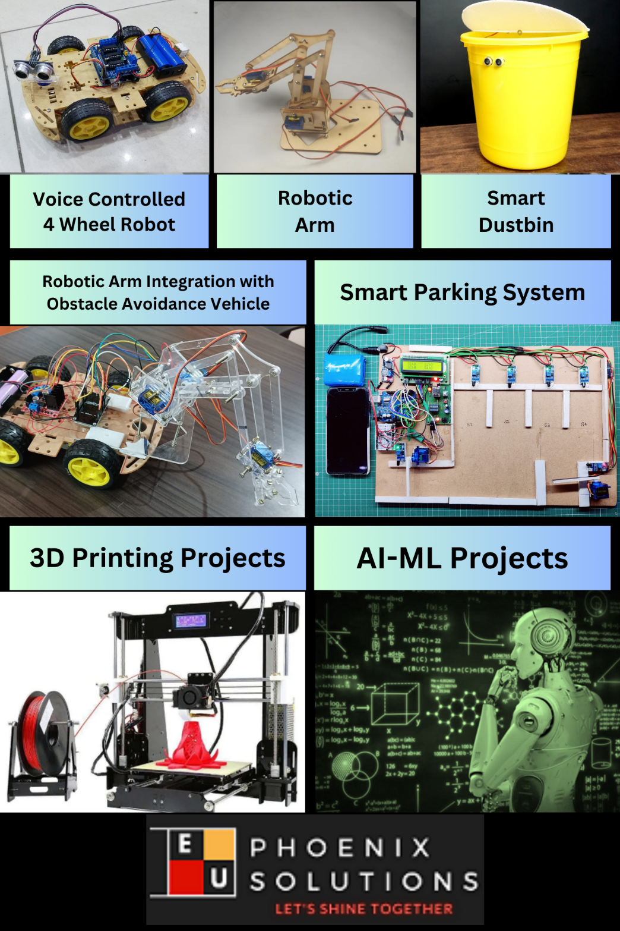

Figure 1.4.1 Company Products

Key components of AI-ML projects include:
Data Collection and Preparation: Projects begin with data collection from various sources such as sensors, databases, or web APIs. Data preprocessing techniques are then applied to clean, transform, and prepare the data for analysis.
Algorithm Selection and Model Development: Students explore different AI and ML algorithms such as regression, classification, clustering, neural networks, and deep learning to build predictive models and solve specific problems.
Model Training and Evaluation: The models are trained using abelled data, and their performance is evaluated using metrics such as accuracy, precision, recall, and F1-score. Hyperparameter tuning and cross-validation techniques are applied to optimize model performance.
Deployment and Integration: Once trained and evaluated, the models are deployed into production environments and integrated with existing systems or applications to deliver real-world value. This may involve deploying models on edge devices, cloud platforms, or IoT devices.

Overall, IoT and AI-ML projects offered by EduPhoenix Solutions provide participants with practical experience, critical thinking skills, and technical expertise in emerging technologies, preparing them for careers in the rapidly evolving fields of IoT and AI-ML.

CHAPTER 2
DOMAIN: FULL STACK DEVELOPMENT

2.1 Introduction
Full Stack Development is a multifaceted and rapidly evolving field at the forefront of modern software engineering. It encompasses the end-to-end development of web applications, from designing user interfaces to managing server-side logic and databases. As technology continues to advance and businesses increasingly rely on digital solutions, the demand for skilled Full Stack Developers has soared.
This introduction provides an overview of Full Stack Development, focusing on its significance in the contemporary tech landscape and the opportunities it presents for aspiring developers. Additionally, it highlights the role of an internship at EduPhoenix Solutions in providing hands-on experience and professional growth in this dynamic field.
Full Stack Development has emerged as a pivotal discipline in the realm of software engineering, bridging the gap between front-end and back-end development. Front-end development involves creating visually appealing and user-friendly interfaces using technologies like HTML, CSS, and JavaScript, while back-end development entails building the server-side infrastructure and database management systems that power web applications.
In recent years, the demand for Full Stack Developers has surged as businesses seek versatile professionals capable of handling diverse aspects of web application development. From startups to multinational corporations, organizations across industries are looking to leverage Full Stack expertise to create innovative digital solutions and enhance their online presence.
An internship at EduPhoenix Solutions provides a unique opportunity for aspiring developers to gain practical experience and insights into the world of Full Stack Development. Through hands-on projects, mentorship from seasoned professionals, and exposure to cutting-edge technologies, interns at EduPhoenix Solutions can develop the skills and knowledge needed to excel in this competitive field.
Throughout this internship, participants will have the chance to work on real-world projects, collaborate with multidisciplinary teams, and contribute to the development of impactful software solutions. Whether designing intuitive user interfaces, optimizing server performance, or implementing security protocols, interns will gain valuable experience across the entire software development lifecycle.
By immersing themselves in the fast-paced environment of Full Stack Development at EduPhoenix Solutions, interns can hone their technical skills, refine their problem-solving abilities, and build a strong foundation for a successful career in software engineering. Additionally, they will have the opportunity to network with industry professionals, attend workshops and seminars, and stay abreast of the latest trends and innovations in the field.

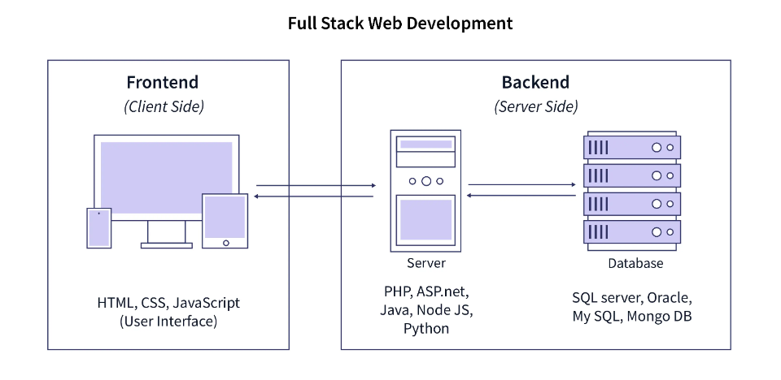
Figure 2.1 Full Stack Web Development
In conclusion, Full Stack Development plays a vital role in shaping the digital landscape of today and tomorrow. An internship at EduPhoenix Solutions offers a gateway to this dynamic field, providing aspiring developers with the resources, guidance, and hands-on experience needed to thrive in the competitive world of software engineering.

2.2 Overview
Full Stack Development is a comprehensive approach to software engineering that involves proficiency in both front-end and back-end technologies, enabling developers to build robust and dynamic web applications. At EduPhoenix Solutions, our internship program offers a deep dive into Full Stack Development, providing aspiring developers with the skills, knowledge, and practical experience needed to excel in this rapidly evolving field.
- Front-end Development:
Front-end development focuses on creating visually appealing and user-friendly interfaces that enhance the user experience. Interns at EduPhoenix Solutions learn to leverage technologies such as HTML, CSS, and JavaScript to design responsive and intuitive user interfaces. Through hands-on projects and guided tutorials, interns gain proficiency in front-end frameworks like React, Angular, and Vue.js, enabling them to build interactive and dynamic web applications.
- Back-end Development:
Back-end development involves building the server-side logic and database management systems that power web applications. During their internship, participants learn to design and implement scalable and efficient back-end architectures using technologies such as Node.js, Express.js, and Django. They gain experience in working with databases like MongoDB, MySQL, and PostgreSQL, mastering data modeling, querying, and optimization techniques.
- DevOps Practices:
In addition to mastering development skills, interns at EduPhoenix Solutions are introduced to DevOps practices that streamline the software development lifecycle. They learn about version control systems like Git, continuous integration and deployment pipelines, and containerization technologies such as Docker and Kubernetes. By adopting DevOps principles, interns gain the ability to automate repetitive tasks, increase deployment frequency, and enhance collaboration among development teams.
- Full Stack Integration:
One of the key components of Full Stack Development is integrating front-end and back-end components to create seamless and fully functional web applications. Interns at EduPhoenix Solutions learn to architect and implement end-to-end solutions, ensuring smooth communication between client-side and server-side components. They gain experience in RESTful API development, authentication and authorization mechanisms, and data validation techniques, equipping them with the skills to build robust and scalable applications.
- Project-Based Learning:
At EduPhoenix Solutions, interns have the opportunity to work on real-world projects that mirror industry scenarios and challenges. They collaborate with experienced developers, project managers, and quality assurance professionals to conceptualize, develop, and deploy innovative software solutions. Through project-based learning, interns develop problem-solving skills, learn to work in agile environments, and gain insights into best practices and emerging trends in Full Stack Development.
- Professional Development:
In addition to technical skills, the internship program at EduPhoenix Solutions focuses on fostering professional growth and career readiness. Interns participate in workshops, seminars, and networking events where they learn about resume writing, interview preparation, and job search strategies. They receive mentorship from seasoned professionals, receive feedback on their work, and build a portfolio of projects that showcases their skills and accomplishments.

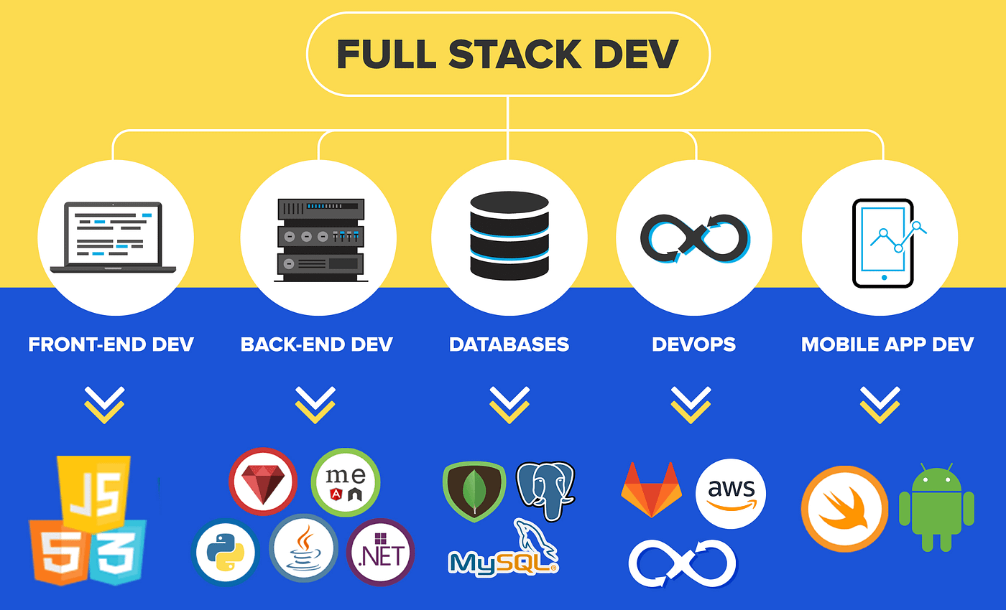
Figure 2.2 Full Stack Overview

2.3 Front-end Development
Front-end development is a critical component of Full Stack Development, focusing on building the user interface and experience of web applications. At EduPhoenix Solutions, interns dive into front-end technologies as part of their comprehensive Full Stack Development internship program. Here's an overview of the front-end technologies covered:
- HTML (Hypertext Markup Language):
HTML forms the backbone of web development, providing the structure and content of web pages. Interns learn to write semantic and accessible HTML code, understanding elements, attributes, and document structure. They gain proficiency in creating responsive layouts, forms, and semantic markup to ensure compatibility across different browsers and devices.
- CSS (Cascading Style Sheets):
CSS is used to style and enhance the visual presentation of HTML elements. Interns at EduPhoenix Solutions learn CSS fundamentals, including selectors, properties, and values, to create visually appealing and responsive web designs. They explore advanced CSS techniques such as flexbox and grid layout to achieve complex page layouts and implement modern design trends.
- JavaScript:
JavaScript is a powerful programming language that adds interactivity and dynamic behavior to web pages. Interns delve into JavaScript fundamentals, including variables, data types, functions, and control structures. They learn to manipulate the DOM (Document Object Model), handle events, and perform client-side validation to enhance user interaction and experience.
- Front-end Frameworks:
Front-end frameworks like React.js, Angular, and Vue.js are widely used to streamline the development of complex web applications. Interns at EduPhoenix Solutions gain hands-on experience in one or more of these frameworks, learning to build reusable components, manage state, and handle routing for single-page applications (SPAs). They explore component-based architecture, state management libraries, and reactive programming paradigms to develop robust and scalable front-end solutions.
- Responsive Design and Accessibility:
In today's digital landscape, ensuring web applications are accessible and responsive across various devices and screen sizes is crucial. Interns learn responsive design principles and techniques such as media queries, viewport settings, and flexible layouts to create adaptive and mobile-friendly user interfaces. They also focus on accessibility best practices, including semantic HTML, ARIA roles, and keyboard navigation, to ensure web content is accessible to users with disabilities.

- Web Performance Optimization:
Front-end optimization plays a significant role in improving the speed and performance of web applications. Interns explore techniques such as code minification, image optimization, lazy loading, and caching to optimize page load times and enhance user experience. They leverage browser developer tools and performance monitoring tools to identify and address performance bottlenecks in web applications.
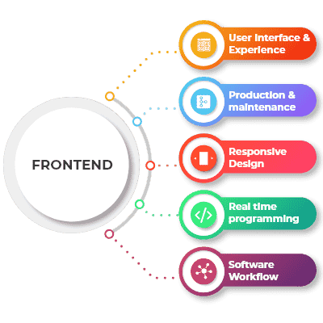
Figure 2.3 Front-end Development
Overall, front-end technology forms a crucial part of the Full Stack Development curriculum at EduPhoenix Solutions, equipping interns with the skills and knowledge needed to create interactive, user-centric web applications. Through hands-on projects and guided tutorials, interns gain proficiency in HTML, CSS, JavaScript, front-end frameworks, responsive design, accessibility, and web performance optimization, setting them on the path to becoming proficient Full Stack Developers.

2.4 Back-end Development
Back-end development is an essential aspect of Full Stack Development, focusing on the server-side logic and database management of web applications. At EduPhoenix Solutions, interns undergo comprehensive training in back-end technologies as part of their Full Stack Development internship program. Here's an overview of the back-end technologies covered:
- Server-Side Programming Languages:
Interns at EduPhoenix Solutions learn server-side programming languages such as Node.js, Python, Ruby, and Java to build the business logic and functionality of web applications. They gain proficiency in writing server-side code to handle client requests, process data, and interact with databases. Each programming language has its strengths and use cases, and interns explore the syntax, features, and best practices associated with their chosen language.
- Frameworks and Libraries:
Back-end frameworks and libraries provide tools and utilities to streamline the development process and maintain code efficiency. Interns delve into popular back-end frameworks like Express.js for Node.js, Django for Python, Ruby on Rails for Ruby, and Spring Boot for Java. These frameworks offer built-in features such as routing, middleware support, authentication, and database ORM (Object-Relational Mapping) to accelerate development and ensure code scalability and maintainability.
- Database Management Systems (DBMS):
Understanding database management is crucial for storing, retrieving, and manipulating data in web applications. Interns learn about relational database management systems (RDBMS) like MySQL, PostgreSQL, and SQLite, as well as NoSQL databases like MongoDB and Firebase. They gain hands-on experience in designing database schemas, writing SQL queries, and implementing CRUD (Create, Read, Update, Delete) operations to interact with data effectively.
- RESTful APIs:
Representational State Transfer (REST) is a popular architectural style for designing networked applications. Interns explore RESTful API development principles and learn to design, implement, and consume RESTful APIs using their chosen back-end framework. They understand concepts such as HTTP methods, status codes, resource endpoints, request/response payloads, and authentication mechanisms to build robust and scalable API endpoints for web applications.
- Authentication and Authorization:
Securing web applications is paramount to protect sensitive data and user information. Interns study authentication and authorization mechanisms such as JSON Web Tokens (JWT), OAuth, and session-based authentication. They implement user authentication workflows, password hashing, role-based access control (RBAC), and token-based authentication to ensure secure access to web resources and prevent unauthorized access.
- Middleware and Services:
Middleware components and third-party services play a crucial role in enhancing the functionality and performance of web applications. Interns learn to integrate middleware modules, such as logging, error handling, caching, and compression, into their back-end applications to improve reliability and efficiency. They also explore cloud services like AWS (Amazon Web Services), Google Cloud Platform, and Microsoft Azure for hosting, storage, and deployment of web applications.
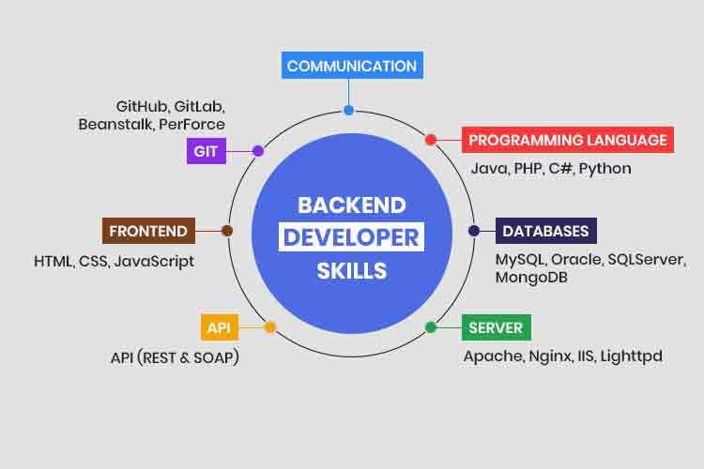
Figure 2.4 Back-end Skills
By gaining proficiency in back-end technologies, interns at EduPhoenix Solutions acquire the skills and knowledge needed to build scalable, secure, and feature-rich web applications. Through hands-on projects, collaborative exercises, and mentorship from experienced professionals, interns develop a strong foundation in back-end development, setting them on the path to becoming proficient Full Stack Developers.

2.5 DevOps
DevOps plays a crucial role in modern software development processes, facilitating collaboration between development and operations teams to streamline workflows, improve efficiency, and enhance the quality of software delivery. At EduPhoenix Solutions, interns undergo comprehensive training in DevOps practices as part of their Full Stack Development internship program. Here's an overview of DevOps in Full Stack Development:
- Continuous Integration (CI):
Interns learn about continuous integration practices, where code changes are automatically integrated into a shared repository multiple times a day. They gain proficiency in using CI tools like Jenkins, GitLab CI/CD, and Travis CI to automate the build, test, and deployment processes. By implementing CI pipelines, interns ensure that new code changes are tested and validated continuously, reducing integration issues and enabling faster feedback loops.
- Continuous Delivery (CD):
Continuous delivery focuses on automating the deployment process to release software updates reliably and frequently. Interns explore CD practices such as automated deployment pipelines, blue-green deployments, and canary releases to deliver changes to production environments efficiently. They learn to configure deployment scripts, manage environment configurations, and monitor deployment metrics to ensure successful releases with minimal downtime.
- Infrastructure as Code (IaC):
Infrastructure as Code enables the automation and management of infrastructure resources using code-based configurations. Interns gain hands-on experience with IaC tools like Terraform, Ansible, and CloudFormation to provision, configure, and manage cloud infrastructure resources such as virtual machines, containers, and networking components. By defining infrastructure as code, interns ensure consistency, scalability, and repeatability in infrastructure deployments.
- Containerization and Orchestration:
Containerization technologies like Docker and container orchestration platforms like Kubernetes are essential components of DevOps practices. Interns learn to containerize applications using Docker, package dependencies, and runtime environments into portable containers. They also explore Kubernetes for container orchestration, managing container deployments, scaling applications, and ensuring high availability and fault tolerance.
- Monitoring and Logging:
Monitoring and logging are integral parts of DevOps for identifying and resolving issues in real-time. Interns learn to implement monitoring solutions using tools like Prometheus, Grafana, ELK Stack (Elasticsearch, Logstash, Kibana), and Splunk to collect, visualize, and analyze system metrics, logs, and performance data. By setting up alerts, dashboards, and logging pipelines, interns monitor application health, detect anomalies, and troubleshoot issues proactively.
- Security and Compliance:
Security and compliance are paramount considerations in DevOps practices to protect applications and data from vulnerabilities and ensure regulatory compliance. Interns study security best practices, implement security controls, and integrate security testing into CI/CD pipelines. They explore tools like SonarQube for code analysis, OWASP ZAP for security scanning, and compliance frameworks like PCI DSS and GDPR to enforce security policies and standards.
- Collaboration and Communication:
Effective collaboration and communication are fundamental principles of DevOps culture. Interns learn to collaborate with cross-functional teams, share knowledge, and foster a culture of continuous improvement. They utilize collaboration tools like Slack, Microsoft Teams, and Jira for communication, task management, and collaboration on projects. By embracing transparency, feedback, and knowledge sharing, interns contribute to a collaborative and productive work environment.
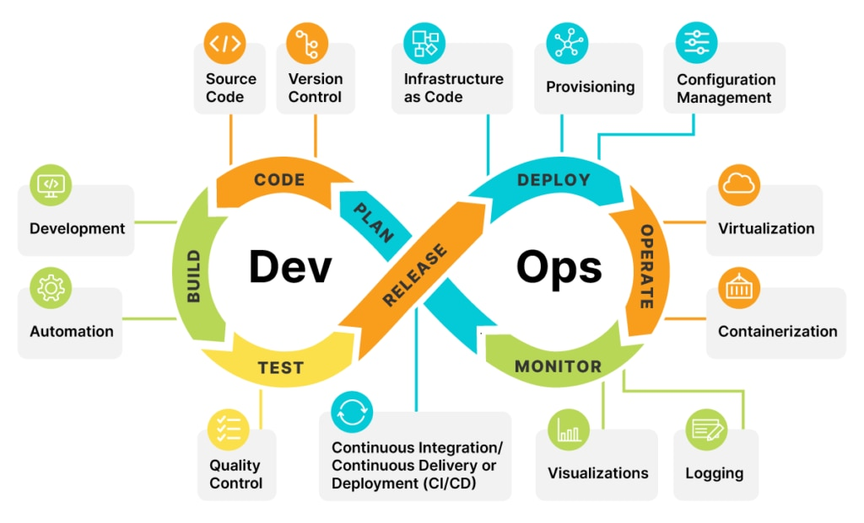
Figure 2.5 DevOps
By mastering DevOps practices, interns at EduPhoenix Solutions acquire the skills and knowledge needed to accelerate software delivery, improve deployment reliability, and enhance the overall development lifecycle. Through hands-on projects, mentorship, and real-world scenarios, interns develop a deep understanding of DevOps principles and methodologies, preparing them for successful careers in Full Stack Development.
2.5 Version Control and Collaboration Tools
Version control and collaboration tools play a crucial role in the software development lifecycle, enabling teams to manage code, track changes, and collaborate effectively. At EduPhoenix Solutions, interns gain exposure to a variety of version control systems (VCS) and collaboration tools as part of their Full Stack Development internship program. Here's an overview of these tools:
- Git:
Git is the most widely used distributed version control system, allowing developers to track changes in their codebase, collaborate with team members, and manage code repositories effectively. Interns learn Git fundamentals, including branching, merging, and resolving conflicts, through command-line interface (CLI) and graphical user interface (GUI) tools like Git Bash, GitHub Desktop, and Sourcetree. By utilizing Git, interns maintain version history, coordinate code changes, and ensure code integrity throughout the development lifecycle.
- GitHub:
GitHub is a web-based hosting platform for Git repositories, providing features for code collaboration, project management, and continuous integration. Interns leverage GitHub for hosting their code repositories, collaborating with peers, and contributing to open-source projects. They utilize GitHub's pull request mechanism for code reviews, issue tracking for bug reporting, and project boards for task management. By participating in GitHub communities and contributing to public repositories, interns enhance their collaboration skills and build a strong developer portfolio.
- SVN (Subversion):
SVN, or Subversion, is a centralized version control system designed for managing software projects and tracking changes to files and directories. Interns learn about SVN's centralized repository model, where all changes are committed to a central server. They work with SVN clients like TortoiseSVN and Subversion command-line tools to perform common version control operations such as checkout, commit, update, and merge. By utilizing SVN, interns understand the principles of version control and collaborate on projects hosted on centralized repositories.
- CVS (Concurrent Versions System):
CVS, or Concurrent Versions System, is one of the earliest version control systems developed for tracking changes in source code files. While less commonly used today, CVS provides basic version control functionalities such as branching, merging, and revision history. Interns explore CVS's client-server architecture and command-line interface to manage code repositories and coordinate team collaboration. They learn about CVS's limitations, including lack of atomic commits and limited support for branching and tagging, compared to modern VCS like Git.

- Mercurial:
Mercurial is a distributed version control system (DVCS) similar to Git, designed for managing projects with distributed development teams. Interns familiarize themselves with Mercurial's decentralized repository model, where each developer maintains a local copy of the repository. They use Mercurial commands like clone, commit, push, and pull to synchronize changes between local and remote repositories. Interns explore Mercurial hosting platforms like Bitbucket and SourceForge for hosting code repositories and collaborating with peers.
- Bazaar:
Bazaar is another distributed version control system that offers an intuitive user interface and a flexible workflow for managing projects of any size. Interns explore Bazaar's feature set, including lightweight branching, decentralized development, and extensibility through plugins. They learn Bazaar commands like branch, commit, merge, and annotate to track changes and collaborate with team members. While less popular than Git and Mercurial, Bazaar provides a viable alternative for version control in specific use cases, such as open-source projects and decentralized teams.
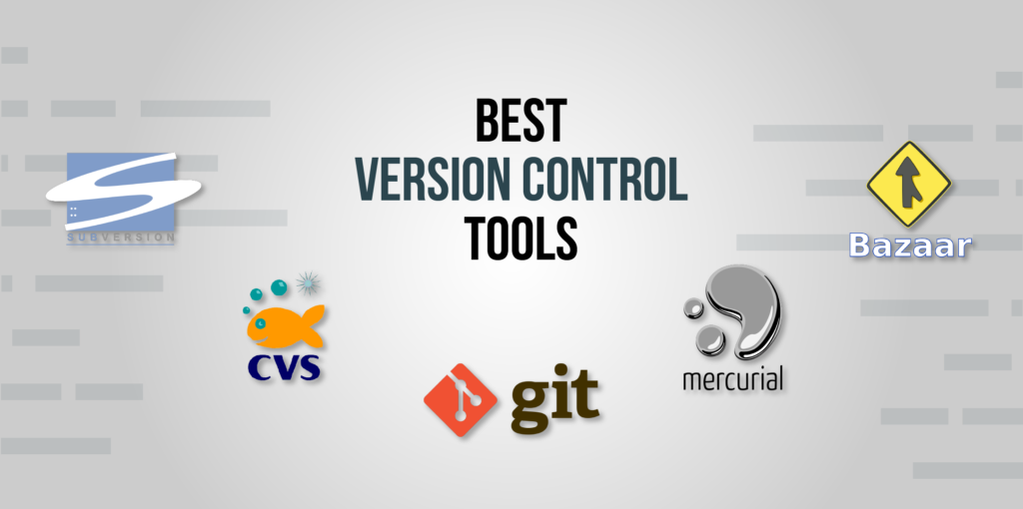
Figure 2.5 Version Control Tools
By gaining hands-on experience with version control and collaboration tools like SVN, CVS, Mercurial, Git, GitHub and Bazaar, interns at EduPhoenix Solutions develop essential skills in code management, collaboration workflows, and project coordination. Through practical exercises, mentorship, and real-world projects, interns enhance their proficiency in version control systems and prepare for successful careers in Full Stack Development.

CHAPTER 3
INTERNSHIP TASK/DAILY-LOGS

CHAPTER 4
PROJECT

CHAPTER 5
CAREER OPPORTUNITIES

As an intern at EduPhoenix Solutions, you'll gain valuable experience and skills that open up numerous career opportunities in the dynamic field of Full Stack Development. Here's a detailed overview of some of the career paths you can pursue:
- Full Stack Developer:
As a Full Stack Developer, you'll be proficient in both front-end and back-end development technologies. You'll work on designing, implementing, and maintaining web applications from start to finish, handling tasks such as user interface design, database management, server-side scripting, and API integration. Full Stack Developers are in high demand across various industries, including technology, e-commerce, finance, healthcare, and more.
- Front-End Developer:
Front-End Developers specialize in creating interactive user interfaces and experiences using HTML, CSS, and JavaScript frameworks like React, Angular, or Vue.js. You'll be responsible for translating design mockups into functional web pages, optimizing web performance, and ensuring cross-browser compatibility. Front-End Developers collaborate closely with UX/UI designers and back-end developers to deliver seamless user experiences.
- Back-End Developer:
Back-End Developers focus on server-side programming and database management to support the functionality of web applications. You'll work with programming languages like Python, Java, PHP, or Node.js to build server-side logic, handle authentication and authorization, and manage data storage using databases like MySQL, PostgreSQL, or MongoDB. Back-End Developers also develop and maintain APIs for communication between the front end and back end of web applications.
- Web Developer:
As a Web Developer, you'll specialize in building and maintaining websites and web applications using a combination of front-end and back-end technologies. You'll work closely with designers, content creators, and other developers to bring digital experiences to life on the web. Your responsibilities will include writing clean and efficient code, implementing user interface designs, integrating with databases and APIs, and ensuring cross-browser compatibility and responsiveness.

- Software Engineer:
Software Engineers in Full Stack Development roles design, develop, and deploy software solutions for various platforms and devices. You'll leverage your skills in programming, software architecture, and system design to create scalable, robust, and secure applications. Software Engineers work on projects ranging from web applications and mobile apps to desktop software and enterprise systems, collaborating with cross-functional teams to deliver innovative solutions.
- UI/UX Designer:
UI/UX Designers focus on creating intuitive and visually appealing user interfaces and experiences for web and mobile applications. You'll use tools like Adobe XD, Sketch, or Figma to design wireframes, mockups, and prototypes, conducting user research and usability testing to gather feedback and improve the user experience. UI/UX Designers collaborate closely with developers to ensure designs are implemented accurately and efficiently.
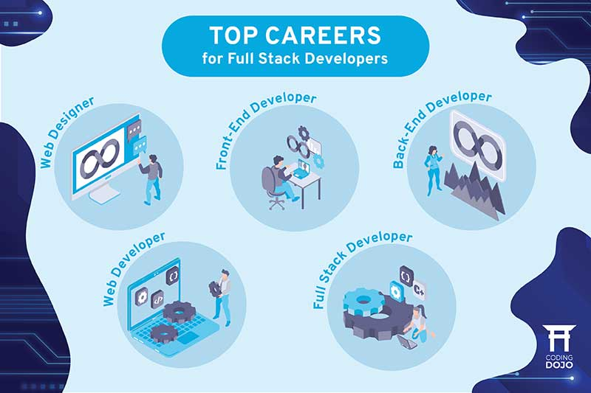
Figure 5 Top Careers for Full Stack Developers
- DevOps Engineer:
DevOps Engineers specialize in automating and streamlining the software development lifecycle through continuous integration, continuous delivery, and infrastructure as code practices. You'll work on configuring and managing deployment pipelines, monitoring system performance, and optimizing workflows for increased efficiency and reliability. DevOps Engineers also play a critical role in ensuring security, compliance, and scalability of software systems.
- Technical Consultant:
Technical Consultants provide expert guidance and support to clients on Full Stack Development projects, helping them identify business requirements, define technical solutions, and implement best practices. You'll leverage your technical expertise and communication skills to collaborate with stakeholders, analyze project needs, and deliver tailored solutions that meet client objectives. Technical Consultants also provide training and documentation to ensure successful project implementation and user adoption.
- Product Manager:
Product Managers oversee the development and launch of software products and features, from concept to delivery. You'll work closely with cross-functional teams, including developers, designers, and stakeholders, to define product requirements, prioritize features, and drive product roadmap execution. Product Managers conduct market research, gather user feedback, and make data-driven decisions to ensure products meet customer needs and business goals.
- Quality Assurance Engineer:
Quality Assurance Engineers focus on testing and validating software applications to ensure they meet quality standards and functional requirements. You'll develop test plans, execute manual and automated tests, and identify and report defects to developers for resolution. Quality Assurance Engineers collaborate with developers and stakeholders to perform regression testing, user acceptance testing, and performance testing, ensuring software reliability and user satisfaction.
These are just a few of the many career opportunities available in Full Stack Development. Whether you're interested in front-end development, back-end programming, system architecture, or project management, there's a diverse range of roles and opportunities to explore in this dynamic field. As an intern at EduPhoenix Solutions, you'll gain the skills, experience, and confidence to pursue a rewarding career path in Full Stack Development and make a meaningful impact in the tech industry.

CHAPTER 6
FUTURE TRENDS
As an intern at EduPhoenix Solutions, it's essential to stay informed about the latest trends and advancements shaping the future of Full Stack Development. Here are some key trends to watch out for:
- Progressive Web Applications (PWAs):
Progressive Web Applications (PWAs) are web applications that leverage modern web technologies to provide a native app-like experience across different devices and platforms. PWAs offer features like offline access, push notifications, and seamless performance, making them increasingly popular for delivering engaging and responsive web experiences. As more businesses prioritize mobile-first development strategies, PWAs are expected to become a standard approach for building cross-platform applications.
- Serverless Architecture:
Serverless architecture, also known as Function as a Service (FaaS), abstracts server management and infrastructure tasks, allowing developers to focus solely on writing code for individual functions or microservices. With serverless computing platforms like AWS Lambda, Azure Functions, and Google Cloud Functions, developers can deploy and scale applications more efficiently, reduce operational overhead, and pay only for the resources consumed during execution. Serverless architecture enables rapid development, improves scalability, and reduces time to market for Full Stack Development projects.
- Jamstack (JavaScript, APIs, Markup):
Jamstack is an architectural approach for building modern web applications that decouples the front end from the back end, relying on pre-built static assets, APIs, and client-side JavaScript to deliver dynamic content and functionality. By leveraging static site generators like Gatsby, Next.js, or Hugo, developers can generate HTML files at build time and serve them through Content Delivery Networks (CDNs) for improved performance and security. Jamstack enables faster page loads, better SEO, and simplified deployment workflows, making it an attractive option for Full Stack Development projects.
- Voice User Interfaces (VUIs):
Voice User Interfaces (VUIs) enable users to interact with applications and devices using natural language commands and voice input. With the increasing adoption of smart speakers, virtual assistants, and voice-activated devices like Amazon Alexa and Google Assistant, there's growing demand for Full Stack Developers skilled in building voice-enabled applications and integrating voice recognition capabilities into web interfaces. VUIs offer opportunities to create innovative and intuitive user experiences across various domains, including e-commerce, healthcare, and home automation.
- Artificial Intelligence and Machine Learning:
Artificial Intelligence (AI) and Machine Learning (ML) technologies are revolutionizing Full Stack Development by enabling intelligent automation, predictive analytics, and personalized user experiences. Full Stack Developers can leverage AI/ML frameworks like TensorFlow, PyTorch, and scikit-learn to build intelligent applications that analyze data, recognize patterns, and make data-driven decisions in real-time. AI-powered chatbots, recommendation engines, and predictive algorithms are just a few examples of how AI and ML are transforming the way we interact with and experience web applications.
- Low-Code and No-Code Development:
Low-Code and No-Code development platforms empower business users and citizen developers to create web applications without extensive coding knowledge or technical expertise. These platforms offer visual interfaces, drag-and-drop tools, and pre-built components to streamline the development process and accelerate time to market. Full Stack Developers can leverage low-code/no-code platforms to prototype ideas, automate repetitive tasks, and collaborate with non-technical stakeholders more effectively. As the demand for custom software solutions grows, low-code/no-code development is becoming an increasingly viable option for building Full Stack applications.
- Cybersecurity and Data Privacy:
With the proliferation of cyber threats and data breaches, cybersecurity and data privacy are top priorities for Full Stack Developers. As technology continues to evolve, developers must implement robust security measures, encryption protocols, and access controls to protect sensitive data and mitigate security risks. By staying abreast of emerging security trends, adhering to industry best practices, and adopting secure coding practices, Full Stack Developers can safeguard applications against cyber threats and ensure compliance with regulatory requirements.
These are just a few of the many future trends shaping the landscape of Full Stack Development. As an intern at EduPhoenix Solutions, you'll have the opportunity to explore these trends, gain hands-on experience with cutting-edge technologies, and contribute to innovative projects that push the boundaries of Full Stack Development. By staying curious, adaptable, and proactive, you'll be well-positioned to thrive in this dynamic and rapidly evolving field.

CHAPTER 7
CONCLUSION

Throughout your internship at EduPhoenix Solutions, you've gained valuable insights and practical experience in Full Stack Development, exploring various technologies, methodologies, and industry trends. As you conclude your internship journey, it's essential to reflect on your learnings and the implications for your future career in Full Stack Development. Here are some key conclusions to consider:
- Holistic Understanding: You've learned front-end and back-end development, equipping you for diverse challenges.
- Collaboration and Communication: Effective teamwork is crucial for project success and client satisfaction.
- Adaptability: Stay curious and update your skills to remain relevant in a rapidly evolving tech landscape.
- User-Centric Design: Prioritize user needs and iterate on design to create engaging experiences.
- Continuous Learning: Commit to lifelong learning to stay ahead in the field of Full Stack Development.
In conclusion, your internship at EduPhoenix Solutions has been a valuable learning experience, equipping you with the knowledge, skills, and mindset needed to excel in Full Stack Development. By leveraging your learnings, embracing new challenges, and remaining dedicated to your professional growth, you're well-prepared to embark on a rewarding career journey in Full Stack Development, making meaningful contributions to the ever-evolving digital landscape.
CHAPTER 8
REFERENCES
- Freeman, A., Robson, J., & Bates, B. (2020). "Head First HTML and CSS: A Learner's Guide to Creating Standards-Based Web Pages." O'Reilly Media.
- Wenzel, T. (2019). "Node.js Web Development: Server-side Development with Node 10 made easy." Packt Publishing.
- Subramanian, P. (2018). "Learning React: A Hands-On Guide to Building Web Applications Using React and Redux." Addison-Wesley Professional.
- Travis, D. (2017). "Mastering Full-Stack React Web Development: Build Scalable, Responsive Web Applications with React, Redux, and GraphQL." Packt Publishing.
- Spolsky, J. (2005). "Joel on Software: And on Diverse and Occasionally Related Matters That Will Prove of Interest to Software Developers, Designers, and Managers, and to Those Who, Whether by Good Fortune or Ill Luck, Work with Them in Some Capacity." Apress.
- Duckett, J. (2014). "JavaScript and JQuery: Interactive Front-End Web Development." Wiley.
- Brown, M. (2017). "Sams Teach Yourself AngularJS, JavaScript, and jQuery All in One." Sams Publishing.
- Flanagan, D. (2011). "JavaScript: The Definitive Guide: Activate Your Web Pages." O'Reilly Media.
- LeBlanc, R., & Gottfried, B. S. (2017). "Java Programming for the Absolute Beginner." Cengage Learning.
- Lin, C. (2017). "Learning Java by Building Android Games: Learn Java and Android from Scratch by Building Six Exciting Games." Packt Publishing.
- Doglio, M. (2018). "Kubernetes for Developers: Use Kubernetes to Develop, Test, and Deploy Your Applications with Confidence." O'Reilly Media.
- Weiss, A. (2017). "Getting Started with Terraform: Manage Infrastructure as Code." O'Reilly Media.
- Hightower, K., Burns, B., & Beda, J. (2017). "Kubernetes: Up and Running: Dive into the Future of Infrastructure." O'Reilly Media.
- McCarty, J. (2015). "OpenShift for Developers: A Guide for Impatient Beginners." O'Reilly Media.
- Holmes, D., & Kennedy, J. (2019). "Microservices in Action." Manning Publications.
- Wiggins, G. (2018). "Docker Deep Dive." CreateSpace Independent Publishing Platform.
- Kopczynski, C. (2017). "Docker: Up & Running: Shipping Reliable Containers in Production." O'Reilly Media.
- Bain, B. (2015). "Terraform: Up and Running: Writing Infrastructure as Code." O'Reilly Media.
- Freeman, A., & Robson, E. (2016). "Head First JavaScript Programming: A Brain-Friendly Guide." O'Reilly Media.
- Stoyanovich, B., & Bares, K. (2016). "Full Stack JavaScript Development with MEAN." Packt Publishing.
- Osmani, A. (2014). "Developing Backbone.js Applications." O'Reilly Media.
- Souders, S. (2007). "High Performance Web Sites: Essential Knowledge for Front-End Engineers." O'Reilly Media.
- Freeman, A., & Robson, E. (2014). "Head First HTML and CSS: A Learner's Guide to Creating Standards-Based Web Pages." O'Reilly Media.
- Duckett, J. (2014). "HTML & CSS: Design and Build Websites." Wiley.
- Shanahan, J. (2018). "Deep Learning with Python." Manning Publications.
- Géron, A. (2017). "Hands-On Machine Learning with Scikit-Learn and TensorFlow: Concepts, Tools, and Techniques to Build Intelligent Systems." O'Reilly Media.
- Chollet, F. (2018). "Deep Learning with Python." Manning Publications.
- Brownlee, J. (2016). "Machine Learning Mastery with Python: Understand Your Data, Create Accurate Models, and Work Projects End-To-End." CreateSpace Independent Publishing Platform.
- Raschka, S., & Mirjalili, V. (2019). "Python Machine Learning: Machine Learning and Deep Learning with Python, scikit-learn, and TensorFlow 2." Packt Publishing.
- Goodfellow, I., Bengio, Y., & Courville, A. (2016). "Deep Learning." MIT Press.

